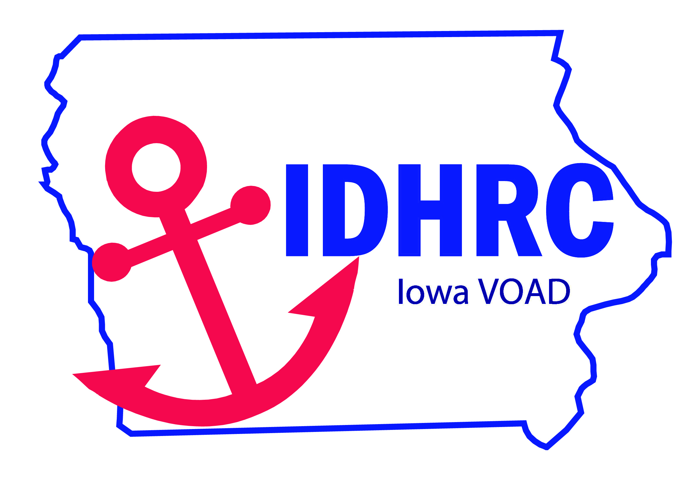  Contact Us  6100 NW 78th Ave  Johnson, Iowa 50131  Phone: 515-725-3288  Email: idhrc@iowa.gov  Web: iavoad.communityos.org |  |  | Iowa Disaster Human Resource Council  IDHRC  - How we began

Table of Contents  Beginnings 1  Mission Statement 2  Focus 2  Critical Partners 3  Early Challenged 3  Key Milestones 4  Our Purpose 4  Transitions. 5  IDHRC Committees…………………………………………………………5 |  |  | Transitions  - IDHRC and members have received state and national recognition  - IDHRC has “grown up”  - 501c3  - Strategic plan  - IDHRC has individuals from the initial coordination meeting still involved today. That speaks volumes!  - Disaster response and recovery is strengthened because we continue to grow and evolve  - IDHRC remains a priority and focus of HSEMD  - Created the Don Hampton Award and combined the award ceremony with a day of training  - Development of the Case Advocacy work and the creation of the Iowa Praise and Prepare Program  IDHRC Committees  The IDHRC Committees work to strengthen Iowa’s capacity to meet the disaster preparedness and disaster response needs of Iowans. The Committees are:  - Community Organizations Active in Disaster  - Spiritual and Emotional Care  - Communication, Marketing and Training  - Volunteers and Donations Management  - Functional Needs/ESF6  - Finance  - Case Advocacy  - Unmet Needs
 |  |  | 5
Key Milestones  - 2008 – EF-5 tornado; statewide flooding; Little Sioux tornado  - Warehouse – setup and maintained  - COAD / LTRC formation – statewide effort  - FEMA “Advice”  - COADs / LTRCs mentored others along with support from FEMA VALs to organize other LTRCs  - Aid Matrix – donations – was the beginning of our donation tracking  - Numerous national partners in the state  “Never doubt that a small group of thoughtful, committed citizens can change the world. Indeed, it is the only thing that ever has.” Margaret Mead  Our Purpose  The IDHRC purpose is to bring together faith-based, voluntary and government organizations active in disaster services to foster a more effective response and recovery for the people of Iowa in times of disaster. |  |  | The Beginnings  Ellen Gordon, EMD Administrator was approached by Iowa Emergency Management Association (IEMA) in 2000 to organize a state level voluntary agency group that could aid in disasters.  Lori Morrissey was the Story County EMA,  was instrumental in the formation of what  we now know as the Iowa Disaster Human  Resource Council.  Joyce Flinn was then tasked with coordination of the group and on December 22, 2000 organizational meeting was held at SEOC.  Some of the partners at the initial meetings were:  County Coordinators  DHS  DPH  IIDRN  American Baptist Men  United Way  Mennonite Disaster Services  Presbyterian Disaster Services  United Church of Christ  American Red Cross  Disaster Child Care  Rotary Club 6000
4 |  |  | 1
Mission Statement  - One of the first things which was done was to create a mission statement and because we wanted to use “spiritual” in the statement.  - We found we needed the Attorney General to approve of using the word “spiritual” in our mission statement.  Coordinate a holistic approach to disaster recovery by maximizing public and private resources thereby providing an efficient system that can address immediate and long-term physical, spiritual, and emotional needs of impacted citizens.  Focus  The Council defined their focus on individuals who would be served by the Council:  - Low income  - Elderly  - Special Needs  This focus hasn’t changed and history has shown it to be the correct focus. |  |  | Critical Partners  Invaluable Support:  - Bernadette Frerker (VAL)  - Dante Gliniecki (MO)  - Missouri was THE program to emulate – “borrowed” all their materials and made them Iowa specific  - Dante always willing to assist – attended many organizational meetings  - Bernadette was instrumental in supporting IDHRC and assisting in coordination during disaster response  - Guidance on formation of local COADs / LTRCs  Early Challenge  NVOAD would not recognize us as a state VOAD because of our name and partners we included. We decided we wanted to include Government agencies in our state VOAD. In the NVOAD model Government should not be involved. Over time the IDHRC model has become accepted and emulated. We chose to include Government because:  Government has programs that can complement IDHRC  Government coordinates response
2 |  |  | 3

